SQL Queries

1)- SELECT COUNT(speed) AS count_airplanes_with_speed,

MIN(speed) AS min_speed,

MAX(speed) AS max_speed

FROM planes

WHERE speed IS NOT NULL;

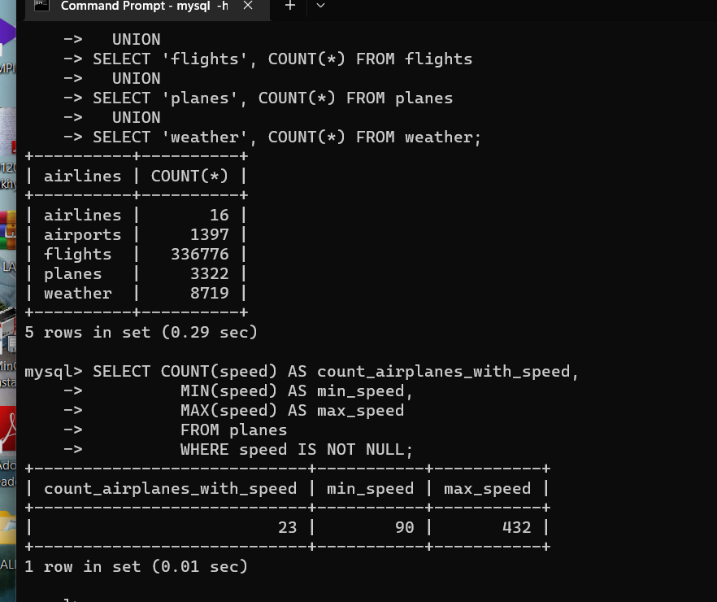

2)- SELECT SUM(distance) AS total_distance_jan_2013,

SUM(CASE WHEN tailnum IS NULL THEN distance ELSE 0 END) AS total_distance_jan_2013_without_tailnum

FROM flights

WHERE year = 2013 AND month = 1;

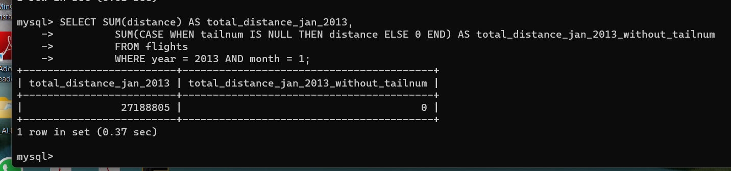

3) – (i)

-- INNER JOIN

SELECT manufacturer, SUM(distance) AS total_distance

FROM flights

JOIN planes

ON flights.tailnum = planes.tailnum

WHERE year = 2013 AND month = 7 AND day = 5

GROUP BY manufacturer;

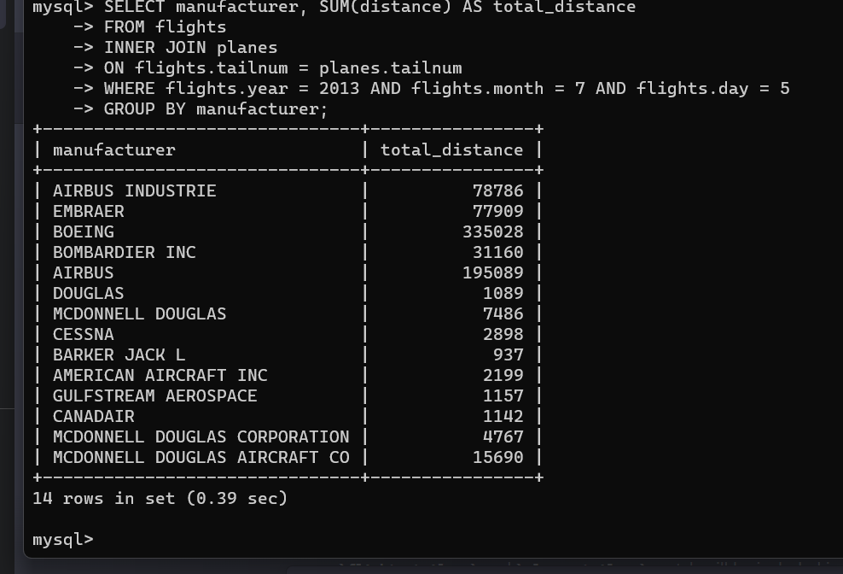

(ii)-

-- LEFT OUTER JOIN

SELECT manufacturer, SUM(distance) AS total_distance

FROM flights

LEFT JOIN planes

ON flights.tailnum = planes.tailnum

WHERE year = 2013 AND month = 7 AND day = 5

GROUP BY manufacturer;

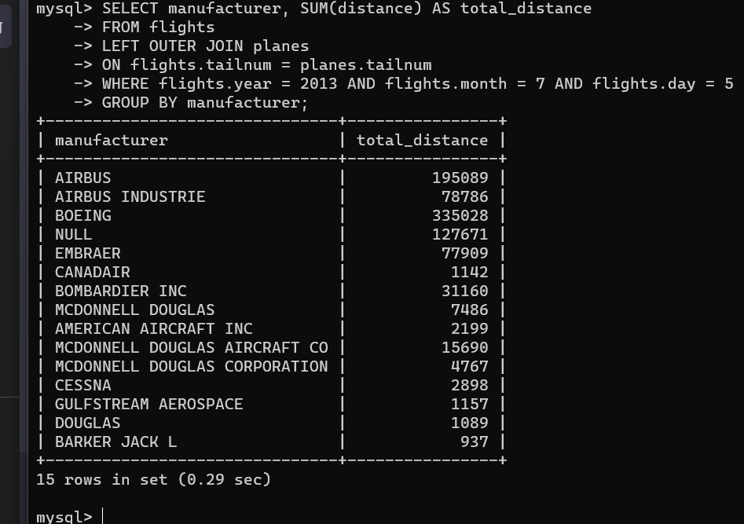

4)-

SELECT manufacturer, SUM(flights.distance) AS total_distance

FROM flights

JOIN planes ON flights.tailnum = planes.tailnum

WHERE flights.year = 2013

GROUP BY manufacturer;

